INSTALLATION
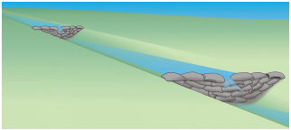Center of rock checks should be 6-inches lower than sides to serve as an overflow.

Rock Check Spacing
Along Slopes

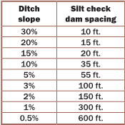
Calculated for 3-foot high rock checks.

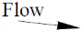
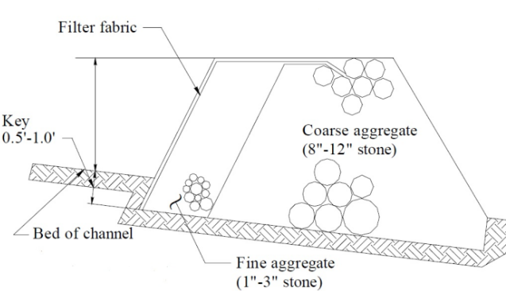
Typical rock check installation.
Contact Information
City of Greendale:
Alan Duncan (812) 553-1559
civilcitysuper@cityofgreendale.net
City of Lawrenceburg:
John Johnson (812) 532-3554
jjohnson@lawrenceburg.in.gov
City of Aurora:
Austin Woods (513) 708-9983
awoods@aurora.in.us
Dearborn County:
Sandy Whitehead (812) 532-2033
swhitehead@dearborncounty.in.gov
Dearborn County Soil & Water Conservation District:
Matthew Simpson (812) 926-2406 Ext. 3
matthew.simpson2@in.nacdnet.net

For more information, please visit www.dearborncounty.org


Brochure Content Sourced From:
Southern Indiana Stormwater Advisory Committee
https://www.siswac.org
CHECK DAMS
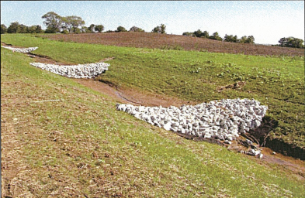
Drainage ditches need temporary silt check dams to capture sediment and reduce ditch bottom-down cutting (erosion). Check dams can be made of rock or stone-filled bags. They are only effective with smaller drainage areas, typically less than 5 acres. See table for correct check dam spacing for various channel slopes.
Overview
- Check dams reduce erosion in a drainage channel by slowing velocity of flows.
- Seed ditches and install silt checks before excavating, filling, or grading uphill areas.
- Inspect, repair, and clean out sediment from upstream side of silt checks after each rainfall exceeding ½ inch, and when silt accumulations have reached ½ the height of the check dam.
- Do not place silt checks in creeks or streams. Sediment must be intercepted before it reaches streams, lakes, rivers, or wetlands.
- Remove temporary silt checks after the site is stabilized and vegetation is established.
- Placing filter fabric under the ditch check during installation will make removal much easier. Stone bag silt checks are easiest to remove and can often be reused.


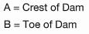
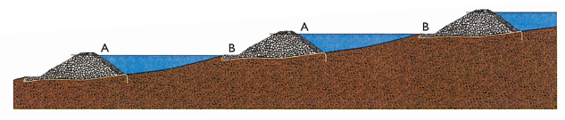
Downstream crest (A) shall be higher than toe (B) of upstream check dam.

INSTALLATION Examples
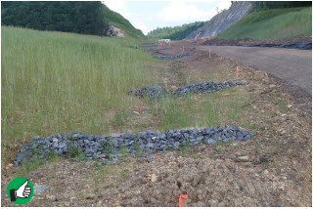
Good installation of low-profile temporary rock silt checks. Remember to tie sides of silt check to upper banks. Middle section should be lower. Clean out sediment as it accumulates.


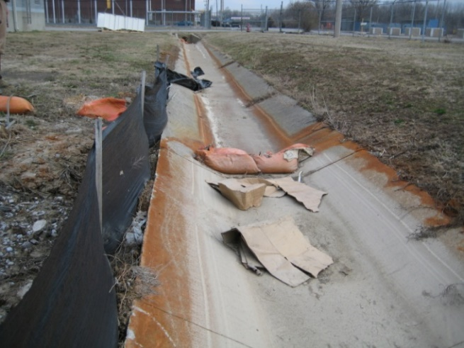
Poor installation of stone-filled bags to serve as check dam. Tied end of bag should be on the downstream end and the center should be lower than the sides.


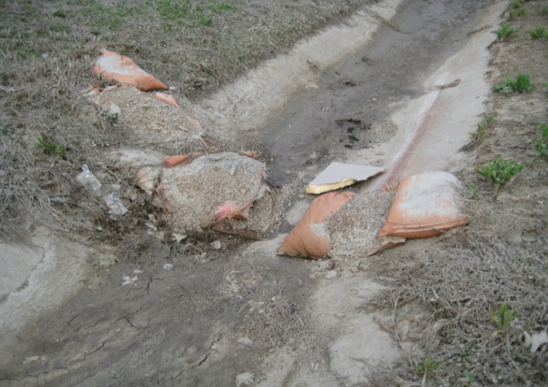
Routine inspections and maintenance are not taking place. Sediment buildup should be cleared, and missing bags replaced.

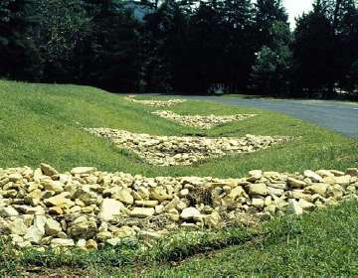
Good installation of rock silt checks is maintained until the project is completely stabilized. Now that the site is stabilized, checks are ready for removal.

